**DS – 5306 Lab #1: Spelling Checker Client & Server**

**Name: Akshay Sarkar; UTA Id: 1001506793**

**Write up of the Lab #1:**

**System Environment:**

Operating System: Windows

Environment Required: Java Virtual Machine

Language: Java

**Instructions for running program:**

1. We need to first put all the files of zip under one directory (E.g. : C:\Client_Server).

“Words.txt” files hold all the words that would be check for Spell Check.

1. (Skip this step if you have already have JAVA_HOME Environment setup in your system)

You need to install Java Virtual Machine in your computer. Follow this [video link](https://www.youtube.com/watch?v=Wp6uS7CmivE) for setup.

1. Once you are completed with Java Environment Setup, now move back to the directory under command line (cmd). Type ‘javac’ to verify the setup completion. (See Below Figure)

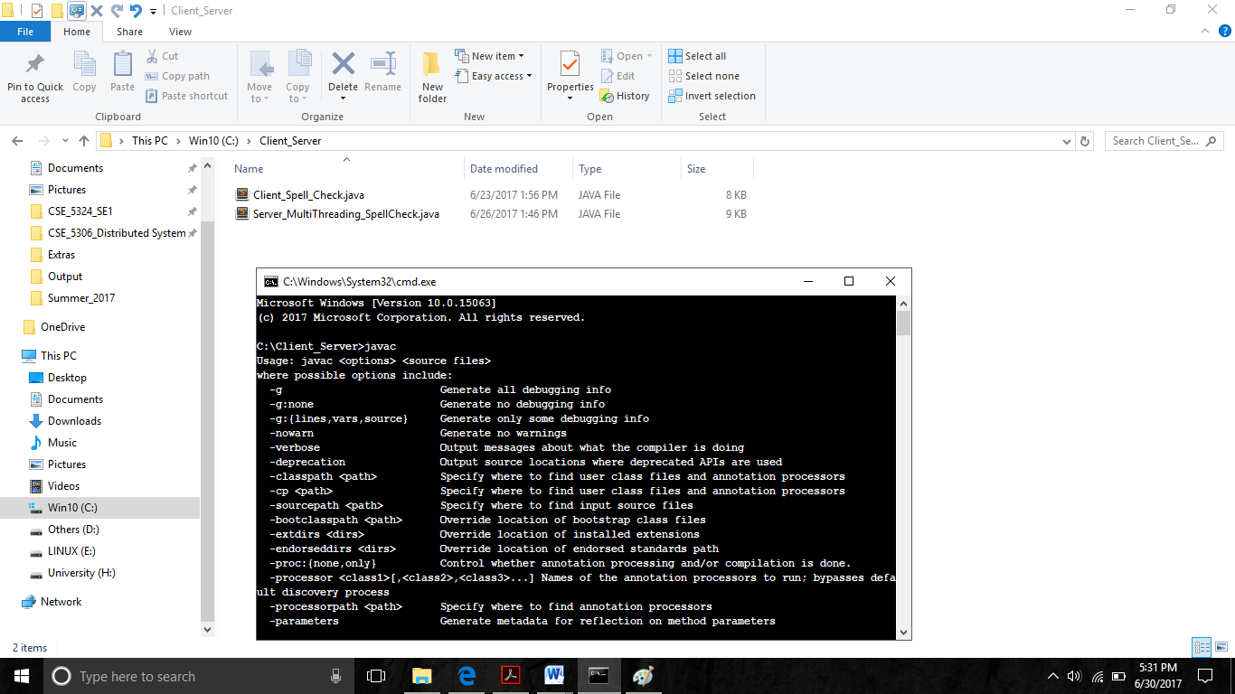

1. Next run the following command in cmd prompt:

* **javac Client_Spell_Check.java**
* **javac Server_MultiThreading_SpellCheck.java**

Above class will generate the .class files which will be used for executing the program.

1. Next step is run the client and Server one by one. Open two command prompts.

* First will run the server, by entering the below command in the command prompt. (See Below Figure)

**java Server_MultiThreading_SpellCheck**

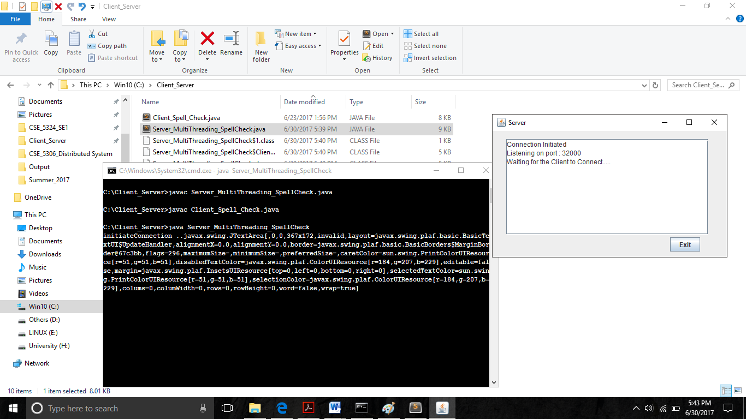

* Second will run the client, by entering the below commands in the next cmd prompt. (See Below Figure). Multiple clients can be created using same steps.

**java Client_Spell_Check**

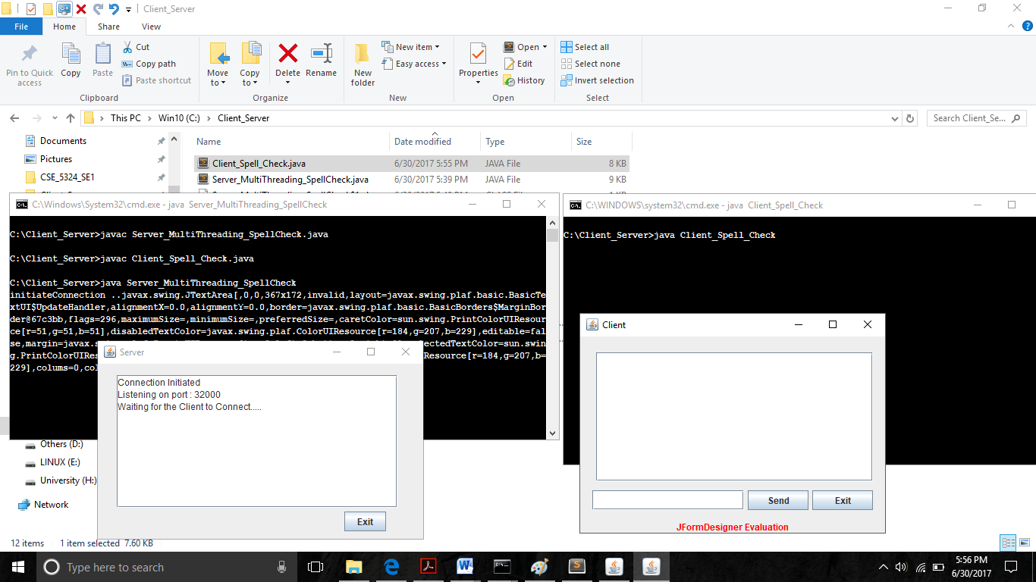

1. Now your application is completely running.

You could start passing sentences or words from Client to Server by entering them into the text-fields. The text-area would show you all the logs that are happening on both client and server.

**Extra Credit:**

1. **Implementation:** Have created a “ClientServiceThread” class on Server Code that would helped to create a multi-threaded server, which takes the each request from client and put it into a separate thread for information exchange.
2. **Verify:** You could add multiple clients by opening multiple cmd prompt and giving the commands for running the client i.e. “**java Client_Spell_Check**”

**References:**

1. <https://www.tutorialspoint.com/javaexamples/net_multisoc.htm>
2. <http://www.mysamplecode.com/2011/12/java-multithreaded-socket-server.html>
3. <http://docs.oracle.com/javase/tutorial/networking/sockets/clientServer.html>

**Zip Contents:**

1. Server_MultiThreading_SpellCheck.java
2. Client_Spell_Check.java
3. Words.txt
4. WriteUp.docx